**Week 7 Sanjana R – 230701285- CSE C**

**Experimenting with Layouts and Color Schemes for an App: Collecting User Feedback on Aesthetics and Usability Using GIMP**

**Aim**

To understand how different colour choices in app UI design affect user experience (UX), particularly in the context of a food ordering application.

**Procedure**

Using GIMP, three different versions of a food ordering app UI were designed, each varying mainly by background colour schemes and minor element color adjustments.  
The layouts were evaluated on factors like:

* Readability
* Mood/message conveyed
* Accessibility
* Visual appeal

**Observation & Analysis**

**Version 1**

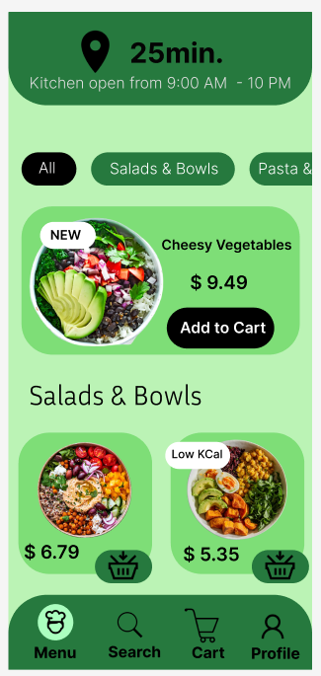

This UI uses a fresh mint green background, combined with darker green highlights for buttons and icons.  
The layout feels energetic, lively, and fresh, aligning well with the theme of healthy salads and bowls.  
The contrast between text/icons and the background is moderate to good, ensuring readability in most conditions.  
However, under bright outdoor lighting, the lighter green background could slightly reduce visibility of the black text and icons.  
Overall, this version conveys positivity, healthiness, and is emotionally uplifting, making it appealing for a food app focused on fresh meals.

**Version 2**

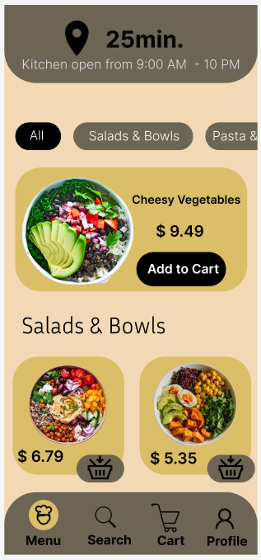

This version features a soft beige background with muted brown headers and elements.  
It gives a cozy, earthy feel, promoting warmth and comfort, which is attractive for a kitchen or food service app.  
The text contrast against the background is excellent, enhancing readability without causing eye strain.  
Navigation buttons are distinctly visible, making the user experience smooth and intuitive.  
The muted tones make the app feel more premium and relaxed, but they may not immediately grab attention compared to brighter palettes.  
This version is ideal for users looking for a soothing and mature visual experience.

**Version 3**

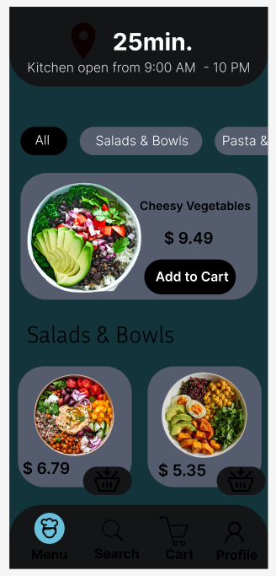

This design uses a dark navy blue background with grey and muted elements.  
The contrast between the white text and the dark background is very strong, The strong colors make it less accessible and less usability.   
However, the darker theme slightly changes the emotional tone: instead of feeling fresh and lively, it feels more serious and formal. The texts aren’t visible.  
It does not fully match the cheerful vibe usually expected from a food ordering app focusing on salads and bowls.

**Results**

After evaluating all three versions of the food ordering app UI, it is clear that colour schemes strongly influence the emotional tone and usability of a design.

* **Version 1** created an energetic and healthy vibe but had slight readability concerns under strong light.
* **Version 2** achieved the best balance between visual comfort, emotional warmth, and readability, making it highly suitable for regular use.
* **Version 3** delivered less usability and accessibility and also conveyed a more formal and less lively mood.

**Conclusion**

This exercise highlighted the importance of balancing emotional appeal, aesthetics, and functionality in UI design.  
An effective colour scheme not only attracts users but also ensures a comfortable and accessible user experience across different conditions